# Media Analysis - AI is not smarter than humans

## Short Summary

The article explores the author's experiences with AI tools like ChatGPT and Siri, praising their utility in communication and business tasks while acknowledging potential limitations in understanding cultural subtleties and maintaining human connections.

## Summary

1. **Opportunities**: The author highlights several opportunities presented by AI tools such as ChatGPT. These include serving as personal assistants to manage tasks like reminders and setting alarms, providing assistance with marketing campaign ideas, helping to craft official letters or resumes, and offering support in brainstorming sessions.  
  
2. **Self-Confidence Boost**: The author mentions how AI tools can enhance self-confidence, particularly in communication. They used the tool to improve their grammar skills and express thoughts more freely.  
  
3. **Business Transformation Potential**: The writer believes that AI could revolutionize business operations, including marketing departments, much like the internet did. This change could potentially streamline processes and generate innovative ideas.  
  
4. **Human-AI Collaboration**: Despite the potential of AI to simplify workloads, the author asserts that human connection remains irreplaceable. They argue that while AI can provide suggestions for personalized content or messages, the final product is still tailored by humans, emphasizing our unique role.  
  
5. **Cultural Understanding Limitations**: The article questions AI's ability to fully understand and replicate cultural nuances. For instance, it's unlikely that an AI can capture the emotional depth of a national celebration or the personal stories behind it.  
  
6. **Language Accessibility**: With advancements in technology, AI tools are expanding their language capabilities beyond English. This expansion could potentially bridge communication gaps among diverse populations worldwide.  
  
7. **Ethical Concerns**: The author refers to Microsoft's Tay incident, a chatbot that was manipulated into generating offensive content within hours of its release, illustrating the risks associated with AI. This highlights the need for robust safeguards and ethical guidelines in AI development and deployment.

## Question 1:

How do the media (in our case = the sample we are analyzing) frame the public discussion about ChatGPT? Are there certain **metaphors** that keep cropping up?

The media frames the public discussion about ChatGPT using metaphors comparing it to human professionals and assistants. Examples include referring to AI tools as 'real-life recruiters, marketers, CEOs' and likening the relationship between humans and AI to that of a virtual assistant.

## Question 2:

Which role does the Arabic World play in the field of Artificial Intelligence in this article according to the author? Answer with 'Not mentioned' if not applicable.

Not mentioned

## Question 3:

How helpful is Artificial Intelligence for the Arabic world based on this article?

The article suggests that AI can be helpful for various tasks, but it does not provide specific examples or analysis related to the Arabic world.

## Question 4:

What is the final message of the article that the author wants to convey? Keep your answer short and precise!

The author concludes that AI is a useful tool but cannot replicate the depth of human connection.

## Sentiment

The sentiment is 4

## Entities

Twitter, Tay, Apple, SAP, Microsoft, Oracle, Saleh, Google Translate, Saint Mary's University, Ali Al-Mustafa

## Topic Clusters

### Cluster: AI Advocacy and Impact on Society

AI advocacy, Human-AI relationship

## Word Clouds

### Wordcloud of content

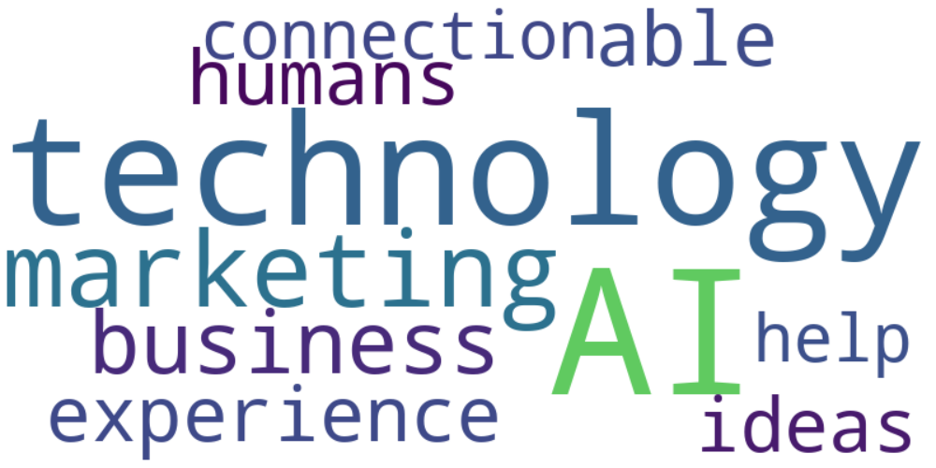

Top 10 words:

- AI: 10

- technology: 8

- marketing: 6

- like: 5

- business: 4

- humans: 3

- experience: 3

- able: 3

- ideas: 3

- connection: 3

### Wordcloud of summary

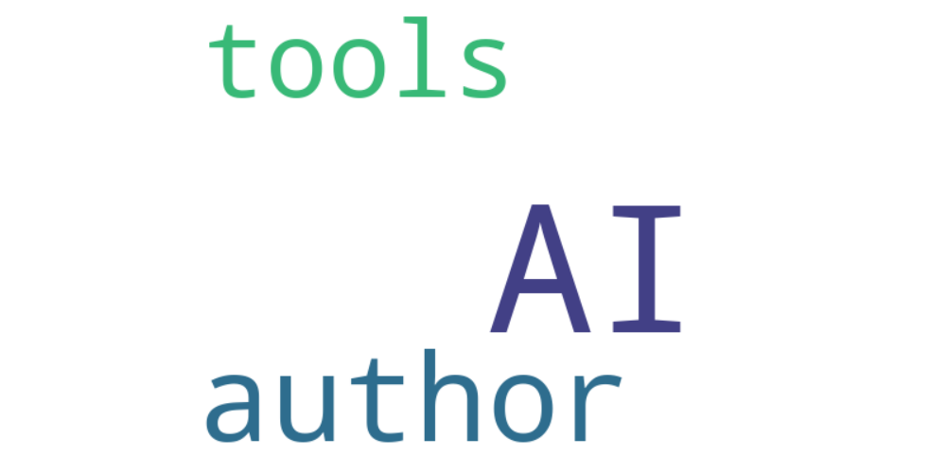

Top 10 words:

- AI: 11

- author: 4

- tools: 3